BLOWFISH ALGORITHM:

Blowfish is an encryption technique designed by Bruce Schneier in 1993 as an alternative to DES Encryption Technique. It is significantly faster than DES and provides a good encryption rate with no effective cryptanalysis technique found to date. It is one of the first, secure block cyphers not subject to any patents and hence freely available for anyone to use. It is symmetric block cipher algorithm.
- blockSize: 64-bits
- keySize: 32-bits to 448-bits variable size
- number of subkeys: 18 [P-array]
- number of rounds: 16
- number of substitution boxes: 4 [each having 512 entries of 32-bits each]
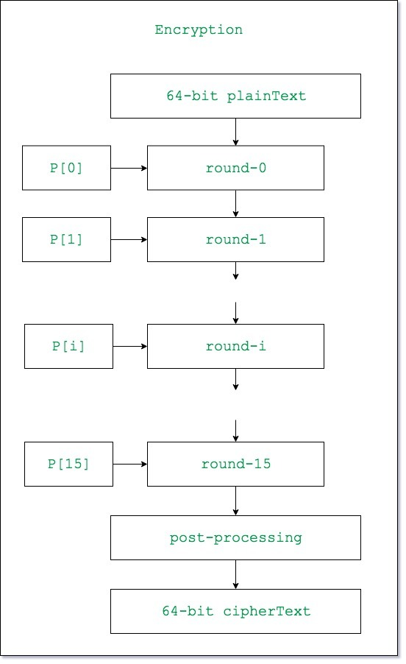
`

Lets see each step one by one:
Step1: Generation of subkeys:
- 18 subkeys{P[0]…P[17]} are needed in both encryption as well as decryption process and the same subkeys are used for both the processes.
- These 18 subkeys are stored in a P-array with each array element being a 32-bit entry.
- It is initialized with the digits of pi(?).
- The hexadecimal representation of each of the subkeys is given by:

P[0] = "243f6a88"
P[1] = "85a308d3"
.
.
.
P[17] = "8979fb1b"
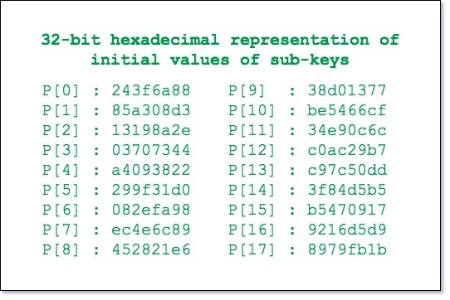

- Now each of the subkey is changed with respect to the input key a
P[0] = P[0] xor 1st 32-bits of input key
P[1] = P[1] xor 2nd 32-bits of input key
.
.
.
P[i] = P[i] xor (i+1)th 32-bits of input key
(roll over to 1st 32-bits depending on the key length)
.
.
.
P[17] = P[17] xor 18th 32-bits of input key
(roll over to 1st 32-bits depending on key length)
The resultant P-array holds 18 subkeys that is used during the entire encryption process
Step2: initialise Substitution Boxes:
- 4 Substitution boxes(S-boxes) are needed{S[0]…S[4]} in both encryption aswell as decryption process with each S-box having 256 entries{S[i][0]…S[i][255], 0&lei&le4} where each entry is 32-bit.
- It is initialized with the digits of pi(?) after initializing the P-array. You may find the s-boxes in here!
Step3: Encryption:
- The encryption function consists of two parts:
a. Rounds: The encryption consists of 16 rounds with each round(Ri) taking inputs the plainText(P.T.) from previous round and corresponding subkey(Pi). The description of each round is as follows:
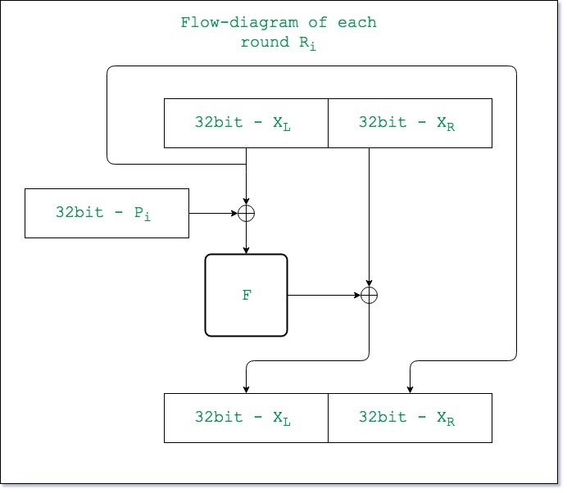

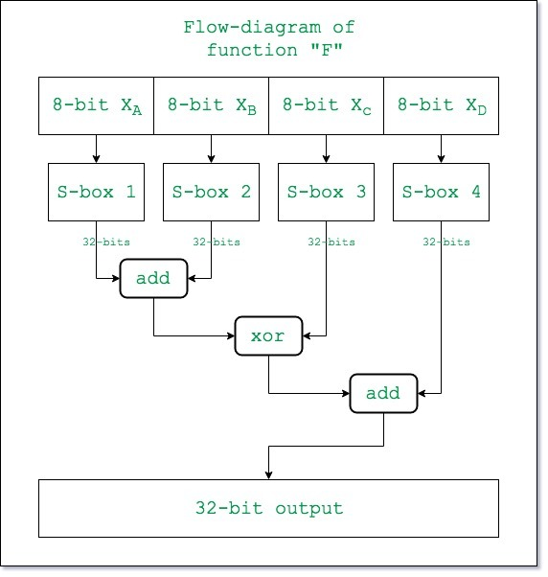

Here the function “add” is addition modulo 2^32.
b. Post-processing: The output after the 16 rounds is processed as follows:

